Interactive Visualization Development Report
Totally, it’s a very long developing project for me. I did this project and learned some new technologies at the same time. To make a long story short, I want to record the mindset challenges and technical problems I faced and describe the solving processes. Of course, there are still something I had not overcome and some new factions and models I want to finish in the future. I’ll also mark them and prepare to sort out.

The worst influence is in the movement controller and relative system. My units (Tanks) couldn't move smoothly like realistic tanks and they will offset on the ground floor. I spent a lot of time to solve it but still wrong, that’s because in the first time, I just took care about the script itself. When I had no ideas to improve my own script, then, I asked my question and the conditions to GPT. Moreover, I also consider it may made wrong method in navigation component,so, I asked GPT and banned the unity’s inner navigation AI and tried to made my own navigate logic. However, it truly gave me some developing script format, but it still couldn’t solve the offset problem. Finally, I did a lot of debug actions and troubleshooted every field. I found the problem was in the collision part. Although I had learn the collision bake component on the internet, I didn’t know the difference between the physically bake and the default bake. The default one will make the units mode occupy the ground floor and got a wrong navigation pathway. After that, the movement logic were be fixed.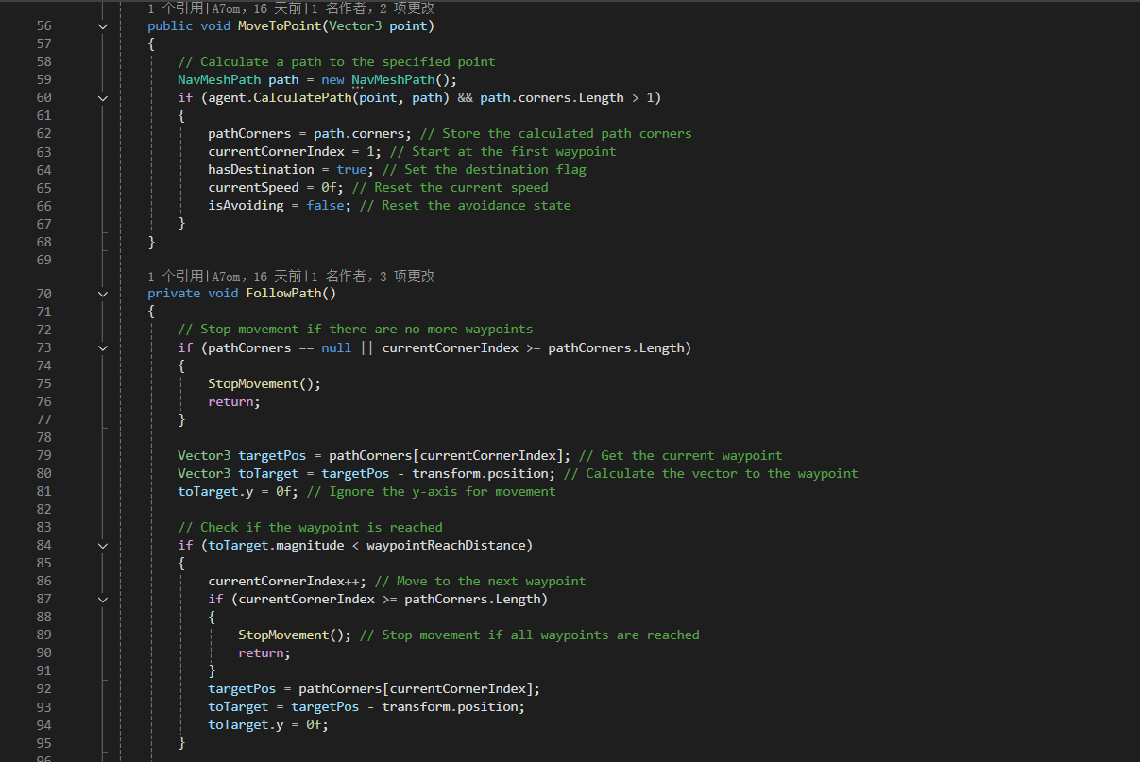

I also need to solve the rotate movements because the default navigation AI in unity is depend on humankind character units. Nevertheless, my units are tanks, they need larger rotation angles and need some smooth preparing actions. I also spent some time to solve it. To solve this problem,I divided the unit’s movement state into two types.
In the first case, when the final destination clicked by the player has only a small turning angle relative to the unit (tank) itself — with the exact threshold being continuously adjusted and refined through testing — the unit will first rotate in place and only then start moving by changing its transform position.
In the second case, when the destination is relatively far away, the unit follows the original movement logic, turning and moving at the same time.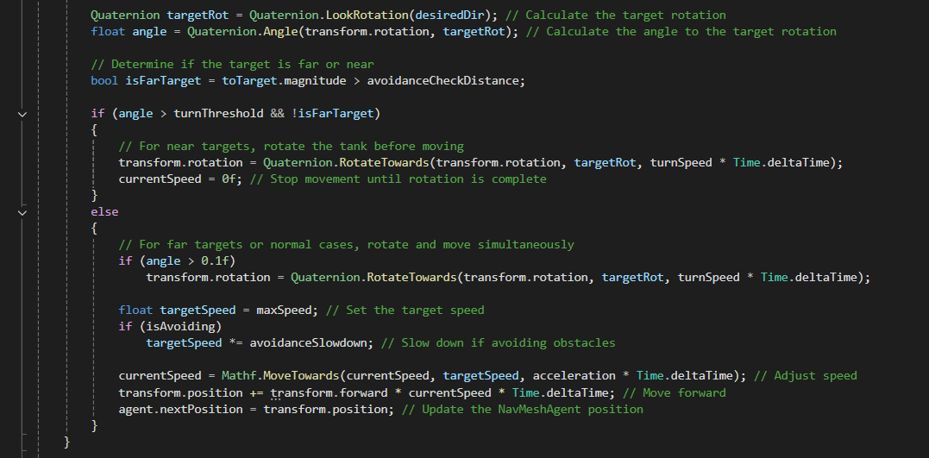

In my earlier technological data review, I had to give up path drawing function because I can not solve the select bug. (It could not cancel the highlight outline appearance when Player click others like ground or others units) However, I finally solved this problem by using different tags and layers. I sorted the units in different tags to make sure they could be find by mouse click function and using different layers to allow the health function and damage function will not be disturbed by movement function. Moreover, the pathway logic itself is very simple to understand, I just utilized a picture as the pathway and ensure the shader graph could constantly update the picture. (make it like a moving track)
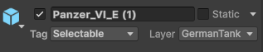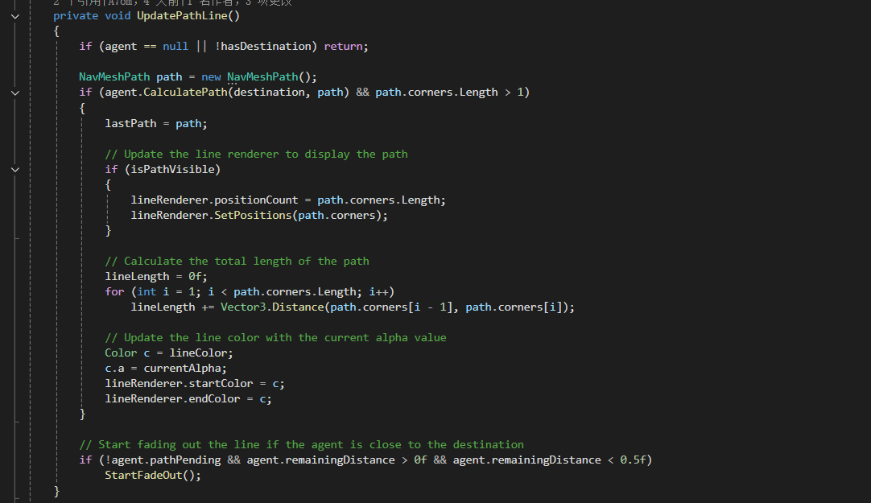

In visual field, firstly, In the garage module, I made the visual function (X-Ray, post processing and shader effects). After my team member Peiyang created the inner models, I made a shader materials to display the tank structure. It is opacity that we can hide and show the inner objects like engine, crews and so on. For the other side, I spent a lot of time in rendering and lighting system because I consider these things are the soul of post processing and ensure a very high quality about the prototype. Key light, fill light, backlight and spot light, all these elements were be involved.
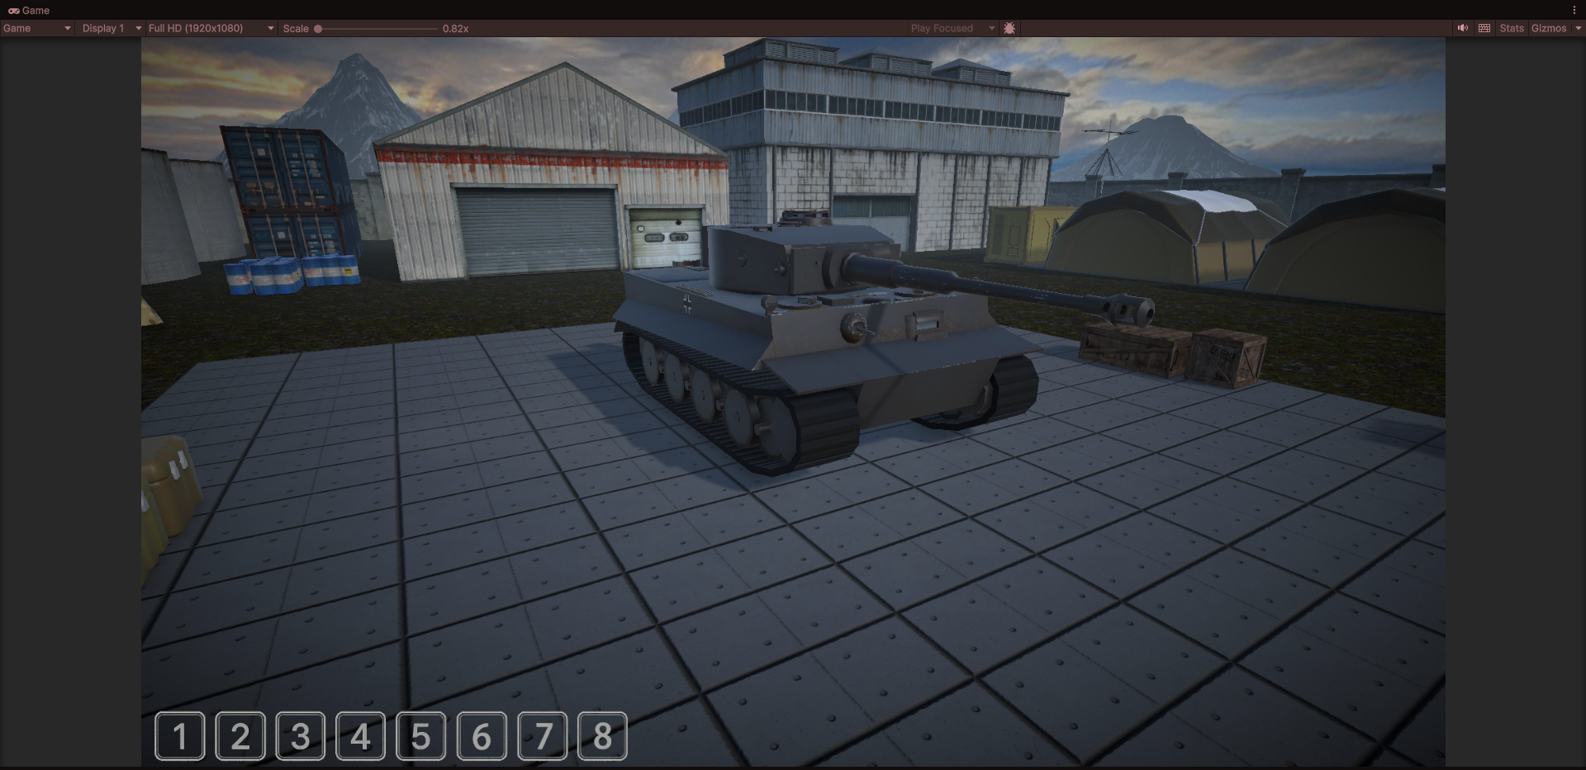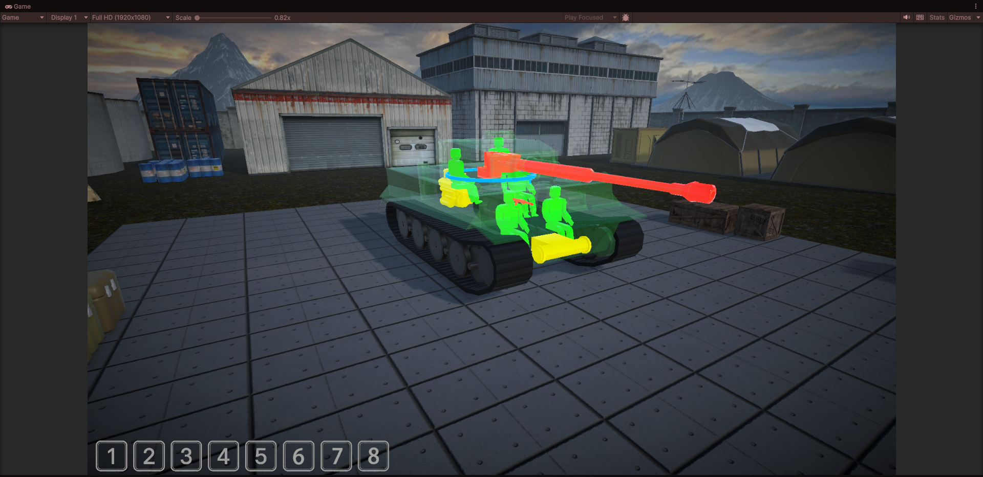

Secondary, In the battle scenery, I also made a set of different post processing settings because it should be separate from the two patterns. The main reason is that the battle scenery need occupied larger internal storage, therefore, I need to change the settings and decrease the GPU costs.
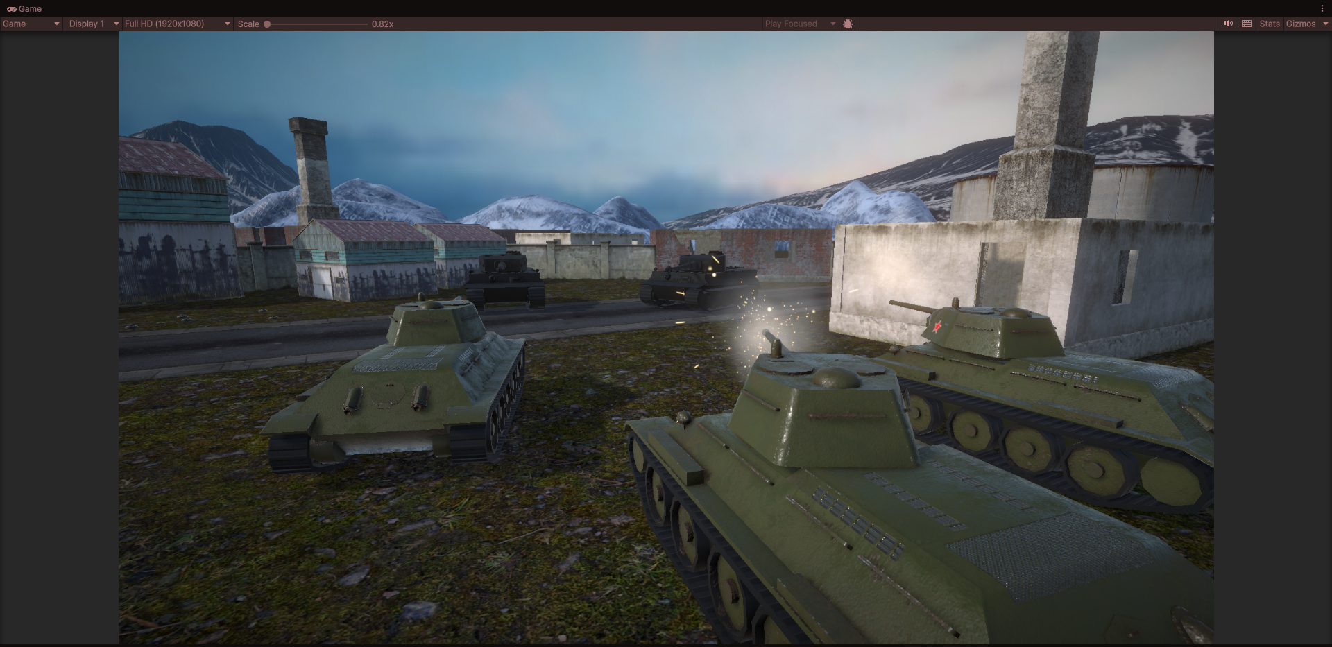

Future Decision: Although this prototype already finished a lot, I still want to develop it again in the future. It has not a complete game loop in battle module (The garage module is finished), I need continually create the damage function and health functions. After that, I want to create an AI enemy, and let one faction will be controlled by this AI. Game mode like Death Match or Occupation will also on my working list.
Overall, I still have many plans that remain to be completed. In order to achieve these goals, I will constantly learn and improve my skills. In the future, I plan to further study code as well as the principles of computer graphics, and to expand my knowledge of shader in particular to achieve a higher-quality final result.

